Ministry of Education, Heritage & Arts 2021 LITERACY WORKSHEET 10
YEAR 2
Lesson: Literacy | Class: 2 | Date:
Objective of the activity:
- Children will name the given picture.

Name each picture correctly. Pick from the table below.
 | 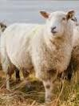
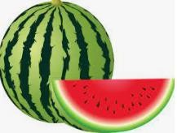 |  | 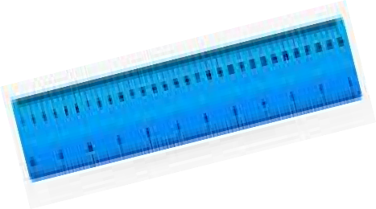
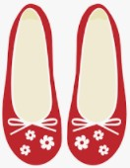 | 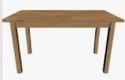 | 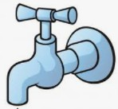

Words

table | house | soap | ruler | coconut
shoes | boat | watermelon | sheep | tap

Instructions to Parents/Guardians
- Find a quiet place to sit with your child and complete the worksheet.
- Make sure that your child’s working space is free and not cluttered.
- Your patience and understanding are greatly needed when completing the worksheet with your child.
- Read and explain the instructions to your child as you go along.
- Repeat the instructions in your mother-tongue if your child does not understand.
- Write the words on a piece of cardboard and go through the words every day. Try to test your child daily.
- Be patient and repeat instructions when necessary.
- Remember to praise your child when she/he attempts the questions.
Impairment | Instructions
For students with Hearing Impairment: | - Provide one to one support.  - Explain to your child that you are looking for the name of each given picture.  - Below the worksheet is a table that have names of the given picture. Use these words to name the pictures.  - Use the internet to look for the sign language for the different pictures.
For students with Vision Impairment: | - Provide one to one support for reading aloud questions and explanations.  - Guide your child as you go through the activity.
For students with Physical Impairment: | - Provide one to one support.  - If your child cannot write, ask him/her to point/touch/look at the picture given and pick from the list the correct name. Assist your child in writing down the answer.
For students with Intellectual Impairment: | - Provide one to one support.  - Explain the objective of the activity clearly.  - Ask your child to say the name of each picture.  - Repeat the name of the picture slowly and ask your child to point to the name of the picture in the table given below the worksheet.  - If your child can’t write, assist him/her to write the answers down.
For students with Learning Difficulties: | - Provide one to one support.  - Explain the objective of the activity clearly.  - Ask your child to say the name of each picture.  - Repeat the name of the picture slowly(3x) and ask your child to point to the correct name given in the table below the worksheet.  - Let your child attempt the activity once you know he/she can do it alone.

